

**YEAR: 8**

**SEMESTER 2, 2017**

**SUBJECT: Science**

**NAME:**

**FORM:** **DATE:**

**Test: Body Systems**

**TIME: 50 minutes**

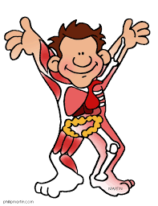

Total

**/60**

**%**

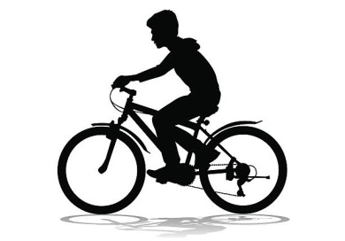

Simon rides his bike to school every morning. He notices that his breathing rate and heart rate change according to how fast he pedals.

1. Identify the body systems working overtime when Simon rides his bike. (2 marks)

**Circulatory system 1 mark**

**Respiratory system 1 mark**

1. What do you know about what’s in Simon’s blood? (10 marks)

**Red blood cells (1 mark) – carry oxygen (1 mark)**

**White blood cells (1 mark) – fight disease (1 mark)**

**Platelets (1 mark) – blood clotting (1 mark)**

**Plasma (1mark) – fluid of blood (1 mark)**

***+ any other 2 suitable comments OTHER THAN those outlined above (e.g. structure of cells, specific types etc.)***

1. Which organ causes Simon’s blood to be pumped around his body? (1 mark)

**Heart**

* 1. Draw and label a very simple diagram of this organ. (4 marks)
  2. Add arrows to your diagram to show the direction of blood flow

through this organ. ( 6 marks)

* 1. Shade and label each side of the organ to show the difference in the

type of blood present. (2 marks)

Right atrium

Left atrium

Left ventricle

Right ventricle

**One mark per label**

**One mark per arrow**

**One mark per shading/label**

1. Explain how the blood is transported around Simon’s body. Describe the function and differences between the types of tubes that the blood travels through. (9 marks)

|  |  |  |
| --- | --- | --- |
| **Name of vessel** | **Function** | **Difference** |
| **Artery (1 mark)** | **Takes blood away from heart (1 mark)** | **Thickest muscular wall of all vessels (1 mark)** |
| **Vein (1 mark)** | **Take blood to the heart (1 mark)** | **Any of: valves, thinner wall than artery (1 mark)** |
| **Capillary (1 mark)** | **Any of: join artery to vein, deliver blood to all of body (1 mark)** | **Wall only one cell thick (1 mark)** |

1. Circle and label the organs which are involved in helping Simon to **breathe**. (5 marks)

[1 mark will be deducted for labelling organs that do not help Simon to breathe]

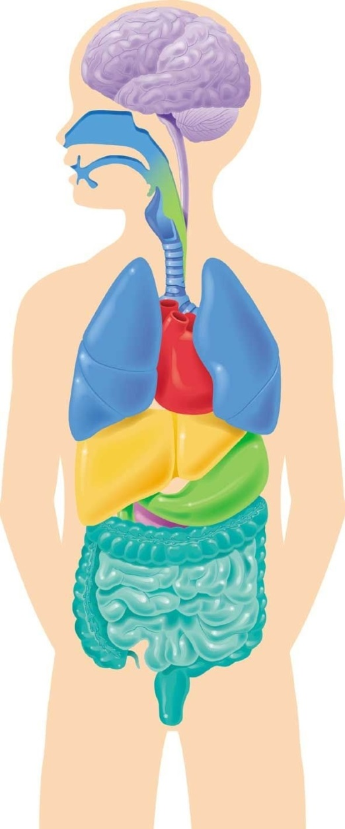

Nose

Mouth

Trachea

Bronchi

Lung (s)

1. Explain how Simon breathes. (14 marks)

|  |  |
| --- | --- |
| **DEFINITIONS: Any of**  **Physical process**  **Exchange of gases**  **Oxygen in, carbon dioxide out** | **1 mark** |
| **BREATHING IN**  **Movement of diaphragm**  **Movement of rib cage**  **Expansion/change in size of chest volume**  **Effect on pressure change**  **Movement of air into lungs** | **1**  **1**  **1**  **1**  **1** |
| **GAS EXCHANGE**  **Air reaches alveoli**  **Oxygen diffuses from alveoli to blood**  **Carbon dioxide diffuses from blood to alveoli** | **1**  **1**  **1** |
| **BREATHING OUT**  **Movement of diaphragm**  **Movement of rib cage**  **Contraction/change in size of chest volume**  **Effect on pressure change**  **Movement of air out of lungs** | **1**  **1**  **1**  **1**  **1** |

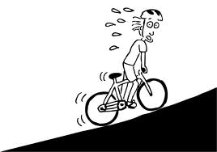On one particular morning Simon decides to take a short cut to school. The short cut that he takes involves a particularly high hill. At the top of the hill he notices that his breathing and heart rate are both much higher than they would be if he was riding on flat road.

1. Explain, using your best scientific knowledge, why **both** the breathing rate and heart rate increases during hard exercise. (7 marks)

|  |  |
| --- | --- |
| **Hard exercise = more energy needed** | **1 mark** |
| **Energy supplied through respiration** | **1 mark** |
| **Any one of: Definition of respiration, equation, chemical process, opposite to photosynthesis** | **1 mark** |
| **Breathing rate increases because more oxygen needed** | **1 mark** |
| **Heart rate increases because blood needs to reach body cells faster** | **1 mark** |
| **As respiration increases, waste carbon dioxide is produced faster and must be removed (or similar)** | **1 mark** |
| **Increased blood flow helps to remove excess heat caused by exercise and respiration** | **1 mark** |



**END OF TEST**

**Please check your work!**



**YEAR: 8**

**SEMESTER 2, 2017**

**SUBJECT: Science**

**NAME:**

**FORM:** **DATE:**

**Test: Reproduction and Survival**

**TIME: 40 minutes**

Total

**/10**

**%**



1. a) Label the two circles of the Venn diagram below indicating the **two` main types of reproduction**.

(2 marks)

**Asexual**  **Sexual**

- Produces more offspring

- Only need on parent

- Simpler

- Exact copy of parent

- NO Variation

- Preserves genetic continuity

- Slower

- Need to find a mate

- More complex

- Mix of parents

- Allows for high amounts of variations

- Better at adapting to environment

- Mutations

* Type of reproduction inliving organisms
* Pass DNA from parent to offspring
* Both produce an new individual

b) In the middle or overlapping section, list the **similarities** between the two types of reproduction.

(2 marks)

c) In the left and right sides, list the **differences** between the two types of reproduction.

(6 marks)

1. 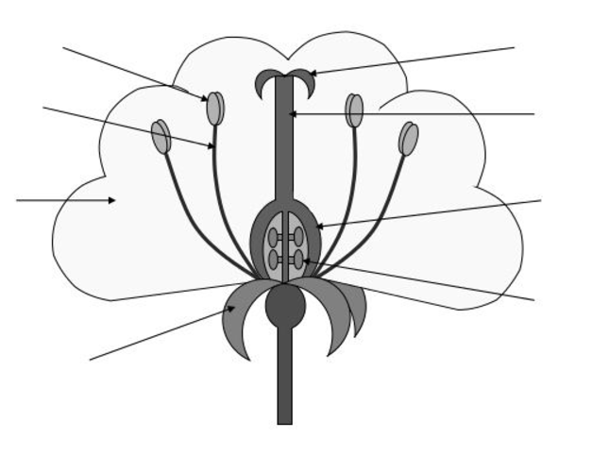Label the diagram of the dissected flower below to identify both the male and female reproductive parts. (8 marks)

Stigma

Anther

Filament

Style

Petals

Ovary

Ovules

Sepals

1. a) Comparing the reproduction of humans and frogs, identify and describe the different methods of **fertilisation** involved for each of these organisms. (4 marks)

External – outside

Internal - Inside

b) Discuss the **advantages** and **disadvantages** of each of these methods.

**One mark for each** – 2 marks per box (8 marks)

Internal

|  |  |
| --- | --- |
| **Advantages** | **Disadvantages** |
| 1. Embryo protected from predators 2. Offspring more likely to survive | 1. More energy required to find a mate 2. Less offspring produced 3. More energy to raise and care for offspring |

External

|  |  |
| --- | --- |
| **Advantages** | **Disadvantages** |
| 1. Little energy required 2. Large numbers of offspring produced 3. Less competition | 1. Any gametes will not survive 2. Many eggs will not be fertilised 3. Most offspring will die – lack of protection. |

1. Complete the following table about **asexual reproduction**: (6 marks)

**Answer any 2 for 6 marks**

|  |  |  |
| --- | --- | --- |
| **Type of asexual reproduction** | **Explanation of how it works** | **Example of an organism that uses this type** |
| **Fission** | **Simplest form of asexual reproduction – one cell splits into two.** | **Bacteria, Amoeba** |
| **Parthenogenesis** | **Unfertilised eggs hatch into new organisms** | **Python, Komodo Dragon** |
| **Vegetative reproduction** | **When one organism is broken into two parts to form two individuals organisms.** | **Starfish, Some Earthworms** |
| **Fragmentation** | **Like fragmentation but for plants that have been designed to have parts break off and form new organisms.** | **. Potatoes, Ginger, Mint** |

**Continue to next page**

During this module you prepared a PowerPoint presentation comparing two body systems of humans with those of different organisms.

1. Provide a short summary of what you know about the similarities and differences of body systems in different organisms. You may include labelled diagrams to help with your explanation.

2 examples of systems – two similarities (2 marks) and two differences (2 marks) within each system = total of 4 marks



**END OF TEST**

**Please check your work!**